Exp No: 17 UART INTERFACING USING INTERRUPT IN KEIL
AIM:
To receive serial data using interrupt.
APPARATUS REQUIRED:
• PC with Windows OS
• Keil µVision IDE
• 8051 Simulator (Keil built-in)
• Serial Window (UART #1)
PROGRAM:
#include <reg51.h>
void serial_ISR(void) interrupt 4
{
if(RI)
{
P1 = SBUF;
RI = 0;
}
}
void main()
{
TMOD=0x20;
TH1=0xFD;
SCON=0x50;
TR1=1;
ES=1;
EA=1;
while(1);
}
OUTPUT:
Before interrupt:
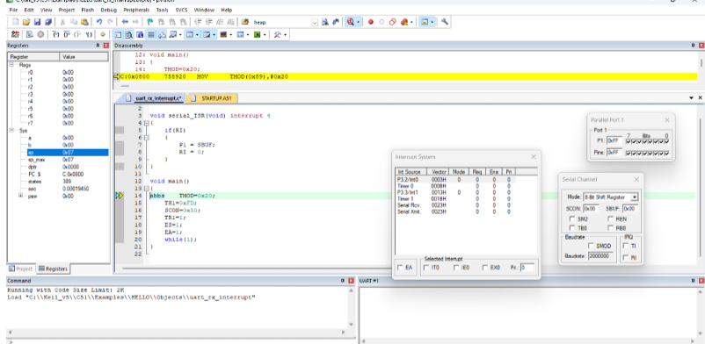
After interrupt:
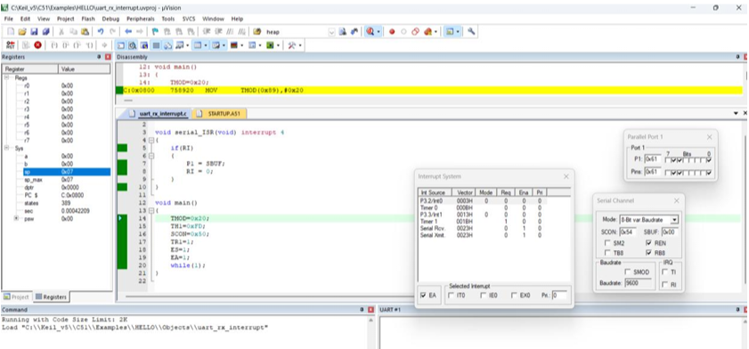
OBSERVATIONS:
Input: Character typed in UART window
Processing: Serial interrupt triggered
Output: Port 1 displays ASCII value of received character.

Typed | ASCII | P1
A | 41H | 0x41
a | 61H | 0x61
1 | 31H | 0xx31

Received serial data appears on Port1.
RESULT:
Thus the serial data was received using Interrupt and the received data was verified

